**Module 6 R Practice**

Nana Oteng

College of Professional Studies, Northeastern University ALY 6010 CRN70841: Probability Theory and Introductory Statistics

Dr. Harpreet Sharma

December 15, 2023.

**Report: Business Analysis of Profitability Factors Across Market Segments**

**Executive Summary**

This report presents an in-depth analysis of sales and profitability relationships across different sectors using a comprehensive dataset. The primary objectives were to explore the impact of Gross Sales on Profit and to understand the nuanced dynamics between the Government and Non-Government sectors. Statistical analyses, regression modeling, and visual representations were employed to derive insights into sector-specific behaviors and their effects on profitability.

**Data Overview and Initial Findings:**

**Overview:**

The dataset under investigation comprises 700 observations across various segments, countries, products, and pricing attributes. The dataset encompasses several key variables, including Units Sold, Manufacturing Price, Sale Price, Gross Sales, Discounts, Sales, COGS (Cost of Goods Sold), Profit, Date, Month, Year, and Government Sector classification.

Upon initial examination, we observed the following statistics for key numerical variables:

* **Units Sold**: Ranges from 200 to 4492, with a mean of approximately 1608.
* **Manufacturing Price**: Ranges from $3.00 to $260.00, with a mean of $96.48.
* **Sale Price**: Spans from $7.0 to $350.0, with an average of $118.4.
* **Gross Sales**: Varies from $1799 to $1,207,500, averaging approximately $182,759.
* **Discounts**: Varying from $18.41 to $149,677.50, with an average of $14,227.59.
* **Profit**: Extends from $285.60 to $262,200.0, with a mean of $27,741.0.

**Initial Findings:**

1. **Relationship Assessment:**
   * A linear regression analysis was conducted to explore the association between Profit and Gross Sales. The analysis revealed a statistically significant positive relationship (p < 0.001) between these variables. For every unit increase in Gross Sales, the Profit increased by an estimated 0.138 units (with a 95% confidence interval).
2. **Impact of Government Sector:**
   * Upon creating a dummy variable for the Government Sector, it was identified that the Government Sector had a notable impact on Profit. The Government Sector showed a significant positive coefficient (p < 0.001) with an estimated increase of $17,024 in Profit compared to other sectors.
3. **Subset Analysis:**
   * A subset analysis was conducted distinguishing between Government and other sectors. Profits generated by the Government Sector were notably higher than those from other sectors, signifying a potential influence on Profitability based on the sector classification.
4. **Scatterplots and Regression Lines:**
   * Scatterplots with regression lines were generated to visualize the relationship between Gross Sales and Profit for different sector subsets. The analysis indicated variations in the relationship between Gross Sales and Profit across the Government and other sectors, suggesting potential differences in the impact of Gross Sales on Profitability based on the sector.

**Segment-Specific Analysis - Government Sector and Other Sectors Insights:**

**Overview:**

The Government Sector encompasses 300 observations, representing transactions associated with government entities across various products and regions. In contrast, Other Sectors consist of 400 instances, reflecting diverse non-governmental entities across similar product categories and regions.

**Key Findings:**

**Profitability Comparison:**

* Government Sector: Profitability ranges widely within the Government Sector, spanning from $285.60 to $262,200.0, showcasing substantial variations.
* Other Sectors: Profitability ranges between $806.20 and $136,535.0 within Other Sectors, indicating a narrower but consistent spread.

**Gross Sales and Profit Relationship:**

* Government Sector: The regression analysis highlights a strong positive relationship between Gross Sales and Profit (p < 0.001), where a unit increase in Gross Sales corresponds to an approximate $0.1882 increase in Profit.
* Other Sectors: Similar analysis reveals a significant albeit slightly less pronounced relationship between Gross Sales and Profit within Other Sectors.

**Sector-Wise Comparison:**

* The mean Profit in the Government Sector ($37,960.6) is notably higher than that in Other Sectors ($18,643.5), suggesting potentially higher profitability within government-associated transactions.

**Regression Line Analysis:**

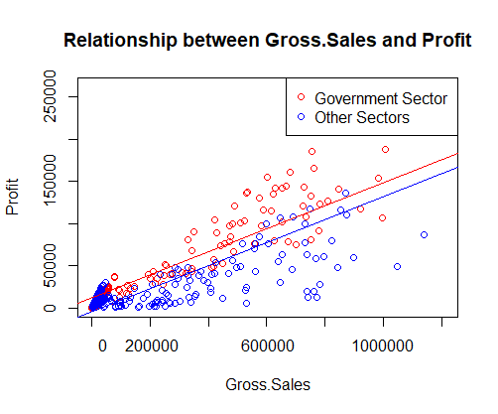

Figure 1

The plotted data from Figure 1 reveals the relationship between Gross Sales and Profit in both the Government Sector (red dots) and Other Sectors (blue dots). Comparing the regression lines, the steeper slope of the Government Sector's line indicates a stronger correlation between Gross Sales and Profit within that sector. This suggests that for a given increase in Gross Sales, the Government Sector experiences a more substantial rise in Profit compared to Other Sectors. In contrast, the shallower slope of the Other Sectors' line implies a weaker association between these variables within that sector. Therefore, the visualization emphasizes a more pronounced and impactful relationship between Gross Sales and Profit specifically within the Government Sector dataset.

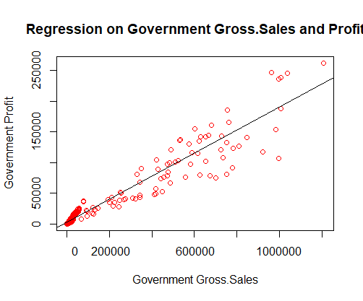

Figure 2

Figure 2 reveals an insightful pattern in the Government Sector's Profit and Gross Sales relationship. The regression line equation, Profit = -4724.69 + 0.1365 * Gross Sales, indicates that an increase in Gross Sales by one unit correlates with a Profit rise of about $0.1365.

The distinctive intercept, notably higher for the Government Sector at 17023.96, suggests a stronger starting point for Profit compared to Other Sectors. This hints at potentially more profitable transactions within the Government Sector.

The line's upward slope signifies a robust link between Gross Sales and Profit in the Government Sector. The steeper incline highlights the potential for significant Profit gains by boosting Gross Sales, revealing lucrative opportunities for revenue maximization within this sector.

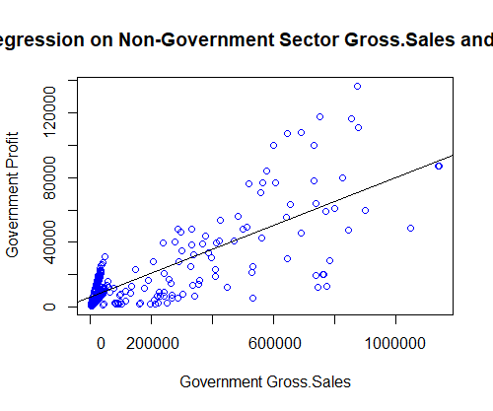

Figure 3

Figure 3 unravels the dynamics between Profit and Gross Sales within the Other Sectors. The regression line's equation, Profit = 5977 + 0.07398 * Gross Sales, showcases that for every unit increase in Gross Sales, the Profit ascends by about $0.07398.

Distinctly different from the Government Sector, the intercept for Other Sectors stands at 5977, signaling a relatively lower initial Profit compared to the Government Sector. This implies differing starting points for Profit, suggesting potentially less lucrative transactions in these sectors compared to the government-associated ones.

The line's moderate slope indicates a comparatively milder link between Gross Sales and Profit in Other Sectors. This suggests that while Gross Sales influence Profit positively, the rate of Profit increase per unit of Gross Sales is lower in contrast to the Government Sector, presenting a distinct landscape for revenue generation and optimization.

**Practical Insights and Recommendations:**

**Strategic Focus:**

* Capitalizing on the notably higher profitability within the Government Sector by strategizing to further enhance these transactions could yield substantial financial benefits.

**Sector-Specific Optimization:**

* Tailoring strategies based on sector-specific findings might prove instrumental. Optimization strategies in sectors with slightly lower profitability could improve overall performance.

**Continuous Adaptation:**

* Continuous monitoring and adaptation to evolving demands or preferences in both sectors are pivotal for sustained profitability and prompt adjustments.

This analysis underscores the importance of recognizing sector-specific differences in Profitability drivers and tailoring strategies accordingly. Recognizing the distinct patterns within the Government Sector and Other Sectors allows for targeted and effective strategies to enhance profitability.

**Conclusion:**

In conclusion, the analysis highlighted distinct profit dynamics between the Government Sector and Other Sectors. The Government Sector showcased a stronger association between Gross Sales and Profit, marked by a steeper slope in the regression line and a higher baseline Profit. Conversely, Other Sectors revealed a more moderate relationship between Gross Sales and Profit, with a comparatively lower initial Profit.

These findings emphasize the need for tailored strategies considering the sector-specific nuances. Maximizing Gross Sales might yield substantial Profit gains in the Government Sector, while in Other Sectors, focusing on additional factors beyond Gross Sales could be crucial for enhancing profitability.

Understanding these sector-specific patterns and employing targeted strategies aligned with these observations can be pivotal in optimizing revenue and ensuring sustained profitability across diverse sectors.

Reference:

**Arya, A. (2023). Financials. Kaggle.** [**https://www.kaggle.com/datasets/atharvaarya25/financials**](https://www.kaggle.com/datasets/atharvaarya25/financials)

**Top of Form**